
CENTENNIAL 25/26 SEASON • FOR IMMEDIATE RELEASE

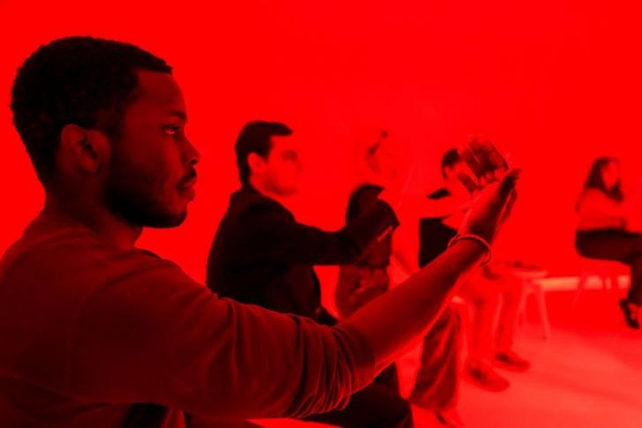

THEATER OF THE MIND, THE ONLY-IN-CHICAGO IMMERSIVE EXPERIENCE CREATED BY DAVID BYRNE AND MALA GAONKAR,
EXTENDS THRU SUMMER TO ACCOMMODATE CONTINUED DEMAND; TICKETS NOW ON SALE THROUGH AUGUST 30

***INTRODUCING A NEW $99 ‘MAKE IT A DATE NIGHT’ PACKAGE***

(CHICAGO, IL | May 7, 2026) With nearly 20,000 tickets sold since Theater of the Mind began performances in March, this only-in-Chicago immersive experience created by Academy, Grammy and Tony Award-winning artist David Byrne with writer Mala Gaonkar, and presented by the Goodman Theatre, has met the demand with a new block of tickets released, extending the run through August 30, 2026, it was announced today by The Goodman Walter Artistic Director Susan V. Booth and Executive Director John Collins. Also announced, a new “Make it a Date Night” package is now available: $99 for two tickets, two complimentary drinks at the Theater of the Mind bar, and a free dessert-for-two with dinner reservations at Nonnina restaurant (340 N. Clark Street), valid for performance time slots starting at 8 pm on Wednesday and Thursday evenings (subject to availability).

“It’s been thrilling to welcome so many people, across generations, to Theater of the Mind—more than half of whom are joining us for the first time,” said Goodman Theatre Walter Artistic Director Susan V. Booth. “We had hoped to create a memorable, out-of-the-box, one-of-a-kind experience for our Centennial Season, and are honored that so many have taken this journey with us—ever grateful for the visionary artistry of David Byrne and Mala Gaonkar.”

Theater of the Mind, recommended for ages 10+, is presented now through August 30, 2026, at the Reid Murdoch Building (333 N. LaSalle). Tickets (starting at $69, subject to change) are available at the Goodman Theatre Box Office (170 N. Dearborn), by calling 312.443.3800 or by purchasing online at TheaterOfTheMindChicago.com. To reserve Date Night tickets for Wednesday and Thursday performance timeslots starting at 8 pm, use promo code DATE.

The Goodman is grateful for the support of Northern Trust, the Chicago Department of Planning and Development, the Alfred P. Sloan Foundation, the Illinois Office of Tourism, and Friedman Properties. Theater of the Mind is produced here in special arrangement with Arbutus, a not-for-profit founded by David Byrne to celebrate, re-present, and amplify ideas found in surprising places.

Directed by Andrew Scoville and Technology Director Heidi Boisvert, PhD, Theater of the Mind is a 75-minute mind-bending sensory journey for 16 audience members at a time. Led by a Guide whose stories are inspired by the creators' lives, audiences explore how they perceive the world through sensory experiments derived from both historical and current neuroscience research that reveal the inner mysteries of the brain.

Company of Theater of the Mind
Co-created by David Byrne and Mala Gaonkar
Directed by Andrew Scoville

Guides: James Earl Jones II, Elizabeth Laidlaw, Helen Joo Lee, Em Modaff, Victor Musoni, AJ Paramo, Shariba Rivers, Kelli Simpkins, and Lucky Stiff
Understudy: Emily Zhang
Assistant Director/Understudy: Maidenwena Alba

Creative Team
Technology Director: Heidi Boisvert, PhD
Technology Producer: LeeAnn Rossi
Scenic Designer: Neil Patel
Costume Designer: Sarita Fellows
Lighting Designer: Jeannette Oi-Suk Yew
Sound Designer: Cody Spencer
Associate Scenic Designer: Lisa Orzolek
Associate Costume Designer: Caryn Klein
Associate Lighting Designer: Brian Elston
Associate Sound Designer: Forrest Gregor
Local Assistant Scenic Designer: Ryan Emmens
Assistant Directors: Maidenwena Alba, Betty Hart, and Amanda Berg Wilson
Production Manager: Matt Marsden
Technical Director: Brian Claggett
Props Department Head: Adam Weiss-Halliwell
General Manager: Karen Berry

Casting is by: Lauren Port, CSA

Performance Schedule
Theater of the Mind is staged Tuesday evenings starting at 5:30 pm; Wednesdays starting at 2 pm; Thursday evenings starting at 5 pm; Friday evenings starting at 5 pm; Saturdays starting at noon; and Sunday afternoons starting at 12:30 pm. Performances begin every 15 minutes, and each includes 16 audience members. A complete schedule can be found at theaterofthemindchicago.com

ABOUT THE GOODMAN

Theater of the Mind makes its Midwest debut during The Goodman’s Centennial 25/26 Season. Since 1925, The Goodman has been a theatrical home for artists and a gathering space for community. It’s where stories come to life—bold in artistry and rich in history, deeply rooted in the city it serves. Led by Walter Artistic Director Susan V. Booth and Executive Director John Collins, The Goodman sparks conversation, connection, and change through new plays, reimagined classics, and large-scale musicals. With distinctions including world and American premieres, Pulitzer Prizes, Tony Awards, and Joseph Jefferson Awards, The Goodman is proud to be the first theater to produce all 10 plays of August Wilson’s “American Century Cycle.” The Goodman believes a more empathetic, more connected Chicago is created one story at a time and counts as its greatest legacy the community it’s built. The Goodman was founded by William O. Goodman and his family to honor the memory of Kenneth Sawyer Goodman—a visionary playwright whose bold ideas helped shape Chicago’s early cultural renaissance. That spirit of creativity and generosity endures today.

###
Photo credit: Todd Rosenberg

Media Contacts:
Beth Silverman | The Silverman Group, Inc.| Beth@silvermangroupchicago.com | 312.560.4783
Denise Schneider |Goodman Theatre | DeniseSchneider@goodmantheatre.org |312.443-5151
Kate Jackson for David Byrne |Grandstand Media |katej@grandstandhq.com

DIGITAL PRESS KIT HERE

