
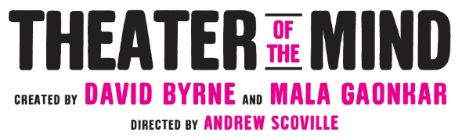

CENTENNIAL 25/26 SEASON • FOR IMMEDIATE RELEASE

ALL-CHICAGO CAST SET FOR THEATER OF THE MIND,
A NEW ONE-OF-A-KIND IMMERSIVE EXPERIENCE CREATED BY DAVID BYRNE AND MALA GAONKAR,
PRODUCED AS A CENTERPIECE OF THE GOODMAN’S CENTENNIAL 25/26 SEASON, STARTING MARCH 11

***DIRECTOR ANDREW SCOVILLE’S CAST FEATURES MAIDENWENA ALBA, JAMES EARL JONES II,
ELIZABETH LAIDLAW, HELEN JOO LEE, EM MODAFF, VICTOR MUSONI, AJ PARAMO, SHARIBA RIVERS,
KELLI SIMPKINS, LUCKY STIFF, AND EMILY ZHANG***

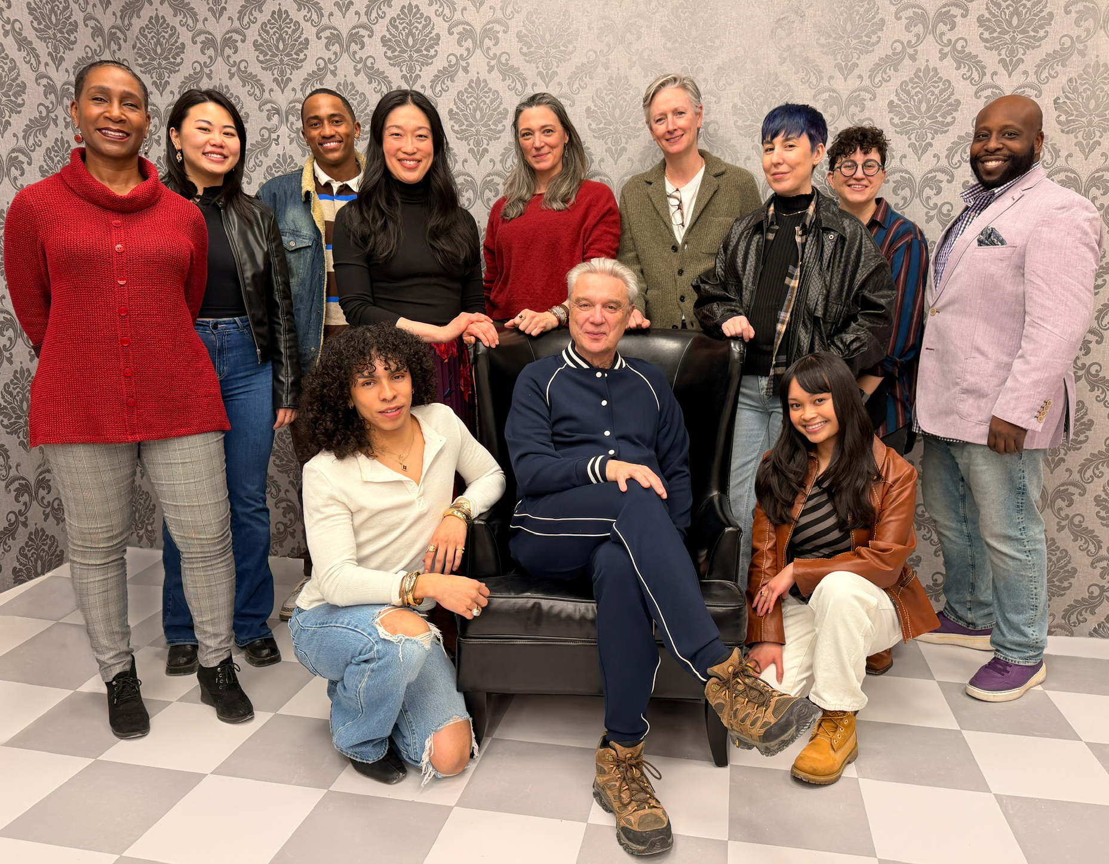
February 9, 2026 (CHICAGO, IL) Goodman Theatre celebrates 100 years and looks to the future with the opening of Chicago’s newest cultural attraction, Theater of the Mind—a one-of-a-kind theatrical immersive experience by Academy, Grammy, and Tony Award-winning artist David Byrne with writer Mala Gaonkar. Today, director Andrew Scoville proudly announces the 11-member, all-Chicago cast who will steward the 75-minute journey of self-reflection, discovery and imagination: James Earl Jones II (Gershwin’s Porgy and Bess and Come from Away national tours), Elizabeth Laidlaw (Goodman’s The Penelopiad, The Rose Tattoo) Helen Joo Lee (Goodman’s A Christmas Carol), Em Modaff (Paramount Theatre’s Fun Home, School of Rock), Victor Musoni (Chicago Shakespeare’s Rome Sweet Home, Definition Theatre and Goodman’s Fat Ham), AJ Paramo (Goodman’s Revolution(s)), Shariba Rivers (American Players Theatre’s The Barber and the Untamed Prince, A Midsummer Night’s Dream), Kelli Simpkins (MCC’s Charm), Lucky Stiff (Goodman’s A Christmas Carol), and understudies Maidenwena Alba (Albany Park Theater Project’s Port of Entry) and Emily Zhang (Strawdog Theatre’s The F*ck House). Theater of the Mind appears March 11 – May 31, 2026, at the Reid Murdoch Building (333 N. LaSalle). Tickets ($66-$96, subject to change) are available at the Goodman Theatre Box Office (170 N. Dearborn), by calling 312.443.3800 or by purchasing online at TheaterOfTheMindChicago.com.

"We are so proud to welcome Theater of the Mind with its fantastic company of Chicago’s boldest actors to the heart of downtown this Spring,” said Goodman Theatre Walter Artistic Director Susan V. Booth. “In planning our Centennial Season, it felt essential to go big—to offer something courageous, wildly creative and new—and double down on what it means to be Chicago’s flagship theater. Unprecedented in size and scope, this is exactly the kind of envelope-pushing project that has long been a hallmark of a theater that has continued to reinvent itself over the past century. We’re grateful to David, Mala and Andrew for this unique collaboration—as well as to those who have shown early support and look forward to sharing Theater of the Mind with our city next month.”

“This city has a wild amount of talent, and I feel so lucky to have this extraordinary group of actors joining Theater of the Mind. Our Guides play such an important role, stewarding each group of audience members through this intimate experience that challenges our perception of reality. I can't wait for this group to lead the way,” said director Andrew Scoville.

The Goodman is grateful for the support of the Alfred P. Sloan Foundation, Illinois Office of Tourism, Northern Trust and Friedman Properties. Theater of the Mind is produced here in special arrangement with Arbutus, a not-for-profit founded by David Byrne to celebrate, re-present, and amplify ideas found in surprising places.

Company of Theater of the Mind
Co-created by David Byrne and Mala Gaonkar
Directed by Andrew Scoville

Guides: James Earl Jones II, Elizabeth Laidlaw, Helen Joo Lee, Em Modaff, Victor Musoni, AJ Paramo, Shariba Rivers, Kelli Simpkins, and Lucky Stiff
Understudy: Emily Zhang
Assistant Director/Understudy: Maidenwena Alba

Creative Team
Technology Director: Heidi Boisvert, PhD
Technology Producer: LeeAnn Rossi
Scenic Designer: Neil Patel
Costume Designer: Sarita Fellows
Lighting Designer: Jeannette Oi-Suk Yew
Sound Designer: Cody Spencer
Associate Scenic Designer: Lisa Orzolek
Associate Costume Designer: Caryn Klein
Associate Lighting Designer: Brian Elston
Associate Sound Designer: Forrest Gregor
Local Assistant Scenic Designer: Ryan Emmens
Assistant Directors: Maidenwena Alba, Betty Hart, and Amanda Berg Wilson
Production Manager: Matt Marsden
Technical Director: Brian Claggett
Props Department Head: Adam Weiss-Halliwell
General Manager: Karen Berry

Casting is by: Lauren Port, CSA

Performance Schedule
Starting March 11, Theater of the Mind will be staged Tuesday evenings starting at 6 pm; Wednesdays starting at 2 pm; Thursday evenings starting at 6 pm; Friday evenings starting at 5 pm; Saturdays starting at noon; and Sunday afternoons starting at 12:30 pm. Performances begin every 15 minutes, and each includes 16 audience members. A complete schedule can be found at theaterofthemindchicago.com

About Goodman Theatre
Theater of the Mind makes its Midwest debut during The Goodman’s Centennial 25/26 Season. Since 1925, The Goodman has been a theatrical home for artists and a gathering space for community. It’s where stories come to life—bold in artistry and rich in history, deeply rooted in the city it serves. Led by Walter Artistic Director Susan V. Booth and Executive Director John Collins, The Goodman sparks conversation, connection, and change through new plays, reimagined classics, and large-scale musicals. With distinctions including world and American premieres, Pulitzer Prizes, Tony Awards, and Joseph Jefferson Awards, The Goodman is proud to be the first theater to produce all 10 plays of August Wilson’s “American Century Cycle.” But The Goodman believes a more empathetic, more connected Chicago is created one story at a time and counts as its greatest legacy the community it’s built. The Goodman was founded by William O. Goodman and his family to honor the memory of Kenneth Sawyer Goodman—a visionary playwright whose bold ideas helped shape Chicago’s early cultural renaissance. That spirit of creativity and generosity endures today.

###
Cast photo caption, credit: Anna Lee Ackermann
David Byrne (sitting), flanked by (back row, from left): Shariba Rivers, Emily Zhang, Victor Musoni, Helen Joo Lee, Elizabeth Laidlaw, Kelli Simpkins, Lucky Stiff, Em Modaff, and James Earl Jones II (front row, from left): AJ Paramo and Maidenwena Alba

Dropbox link with press assets

Media Contacts:
Beth Silverman | The Silverman Group, Inc.| Beth@silvermangroupchicago.com | 312.560.4783
Denise Schneider |Goodman Theatre | DeniseSchneider@goodmantheatre.org |312.443-5151
Kate Jackson for David Byrne |Grandstand Media |katej@grandstandhq.com

